GENERAL RULES:
1.1 All Club members and Visitors must be in possession of a valid fishing licence and fish according to the guidelines.
1.2 The Club promote Catch and Release (Including Carp) Anglers who want to keep fish for personal use must humanely kill the fish after the weigh-in process.
1.3 Club Competitions can consist of day or day-night competitions.
1.4 Competition times:
1.4.1 Day Competition times:
- Meeting and entries at 06h00; competition starts at 07h00 and ends at 15h00
1.4.2 Overnight competition times:
- Same as per Day competitions except the competition will end 12pm on the Sunday. There will also be a weigh-in period of one hour between 15h00 – 16h00 during which anglers will not be allowed to fish or put any feed in the water.
1.5 Should weather conditions be bad and deteriorate to such an extent that normal angling is no longer possible or safe, e.g. lightning, the Officer in Charge (OIC) of the day in consultation with the anglers, may pause, shorten or call the competition off. The Officer In Charge (OIC) must be in possession of an approved lightning meter prior to the commencement of the controlled competition. This lightning meter is an aid to the OIC to determine in time, if a thunderstorm or lightning may create a dangerous situation. Anglers who feel uncomfortable with any situation can stop fishing at any time and do not have to wait for the OIC to give a signal.
These bad weather rules are put in place for the safety of those who are in attendance and anyone who disregard them may be disqualified and or receive additional penalties.
If the circumstances are found to be dangerous, the IOC will immediately take one of the following three actions:
1.5.1 Temporary stoppage:
The OIC will give ONE long signal (12 seconds +) which will require the following actions:
- Anglers who are busy playing a fish will have until the second signal to land and place the fish in the keepnet.
- The time between the first and second signal (12 seconds +) will not be more than 5 minutes.
- Anglers who are not busy playing a fish can, if they want to, make use of this time to immediately and quickly remove their lines from the water and preferably lay all rods on the ground (or at least horizontal) after which you must take shelter at least 7 meter away from your fishing setup.
- The 7 meters does not indicate a safe distance and only serves to assist officials.
- After the second signal no one will be allowed to handle any fishing gear or fish and must remain in a safe place away from their fishing setup.
- A third signal of 12 + seconds will indicate that fishing can resume.
1.5.2 Shortened competition:
The OIC will give TWO long signal (12 seconds +) with a 10 second break in-between which will require the following actions:
- Anglers who are not busy playing a fish must then immediately stand back at least 7 meters.
- Anglers who are busy playing a fish will have until the second signal to land and place the fish in the keepnet.
- The time between the first and second signal (12 seconds +) will not be more than 5 minutes.
- After the second signal, all anglers must immediately then remove their lines from the water and no more fish may be placed in the keep net.
- Weigh-in will then commence as normal.
1.5.3 Cancelled competition:
This will only happen in very rare cases
The IOC will give Four long signals (each 12 seconds +) with 5 second breaks in-between
All anglers must then immediately remove their lines from the water, empty their Keepnets, and pack up if it is safe to do so.
Those who attended will receive 5 Ranking points.
1.6 Anglers attending the competition may not fish in the competition area 48 hours prior to the start of a competition.
1.7 Age categories are as follows:
1.7.1 Seniors: male anglers who turn 19 after 1 July and older.
1.7.2 Ladies: female anglers who turn 19 after 1 July and older
1.7.3 Juniors: male/ female anglers who will be 18 or younger by 30 June.
1.7.4 Mini-Juniors: male/ female anglers who will be 12 or younger by 30 June
1.7.5 Masters: male/ female anglers who will be 50 or older by 30 June.
1.8 Visitors are welcome to participate at Club Competitions but are required to abide by all rules of the Club, venue, and any additional rules set by the OIC of the day. All visitors are required to pay the relevant venue fees for the day. Visitors do not contribute towards a pool fee and are hence not eligible to win the pool money. Visitors are however allowed to participate in the competition standings if it is their intention to join the club. Visitor standings / points can be accumulated for up to 3 months after which it will expire. A Visitor will be required to join the club after the 3rd visit within 12 months.
1.9 The competition area will be announced by the Officer in Charge (OIC) of the day prior to the start of the competition. Anglers are only allowed to sit within the identified competition area which will be split between Conventional and Carp Specimen Anglers. Numbers will be drawn prior to the start of the competition and will be used to determine the order of entry to the competition area or the angler’s allocated peg number.
1.9.1 Order of entry:
This can be used for open or pegged venue competitions. The number you draw determine in which order anglers will drive off to their preferred spot. The angler who draw number 1 will drive off first followed by number 2 about 20 seconds later. Number 2 must first wait for no.1 to park on his preferred spot before no.2 can secure his. The person who draw the last peg will have to settle for what’s left and secure his / their spot last.
Anglers are free to pack up and move within the competition area during the competition times as long as this does not infringe or compromise any other angler already set up in the immediate area. In the event of any dispute the Officer in Charge (OIC) of the day will determine the merits of the dispute and the ruling will be final.
1.9.2 Pegged bank:
Participants will draw a number and sit at the corresponding peg. Those participants who wish to sit together/ families may be issued two adjacent pegs. The second or third pegs will be issued by the Officer in Charge (OIC) of the day and will be a number closer to the centre of the competition area. Pegs will be placed a minimum of 20 meters apart.
Anglers will not be allowed to move during a pegged competition except if there is a valid reason and agreed to by the OIC. The angler will be required to do a redraw from the available pegs.
1.10 Wading is allowed at the discretion of the Officer in Charge (OIC) of the day and will be announced before the competition commences. An angler or their helper may wade to net a fish or to loosen snagged lines etc. However, in the process the angler, or his helper, may not wade deeper than his/her armpit and must stay on his/her feet at all times. Anglers wearing a wader must preferably not wade deeper than their hips. A junior or mini-junior angler may not wade deeper than his/her hips. As safety is of paramount importance, failing to adhere to this ruling may result in immediate disqualification of the angler from the competition.
1.11 No angler except for mini - juniors may receive assistance with casting, striking or playing a fish.
1.11.1 The person assisting the mini – junior with casting must kneel on at least one knee when casting and may not use a rod in excess of 10 ft.
1.12 Anglers are required to tidy up at the end of each competition and leave the area in a condition better than what they found it, i.e. removing all litter, closing gates, etc.
1.13 Fires are allowed on condition that they comply with the state fire service’s rules and regulations.
1.13.1 No open fires are to be made unless they are off the ground in a purpose built container and remain under constant supervision. No signs of a fire may be visible on departure.
1.14 Anglers are to obey any ad hoc instructions issued by the Officer in Charge (OIC) of the day. Ad hoc instructions must be agreed to by at least two Committee members and announced prior to the start of the competition.
1.15 Anglers are to obey the rules as set out by the owners of the facilities we use.
1.16 Anglers must be in possession of a valid fishing licence and also adhere to all the associated angling rules except in the case of catch and release of carp for which we have permission during Bank Angler events.
1.17 Any disputes can be taken up with the Officer in Charge (OIC) of the day.
1.18 Casting must be done from the natural bank or any other place behind the casting line as indicated by placing of the pegs.
2. TACKLE, BAIT AND FEEDING – CONVENTIONAL FISHING:
2.1 Anglers may not use or have more than two rods setup at any time. (Victoria fishing regulation)
2.1.1 Each rod in use must be placed horizontally on a purposely build Conventional fishing stand, pod or two banksticks. (Note: Conventional fishing stands and tackle boxes will in future become mandatory for anglers competing in interstate and international competitions.)
2.2 Each rod must be fitted with a reel and a maximum of two single hooks may be tied to each line.
2.3 No bait boats, boats, canoes or fish finders are allowed during competitions.
2.4 No electrical, electronic or mechanical apparatus to assist the angler in casting bait, indicating a bite or used to strike will be allowed during the competition.
2.4.1 Exceptions to 2.4
- Blind anglers may make use of a bite alarm to indicate bites.
- Day / Night competitions: Anglers will be allowed to make use of bite alarms between sunset and sunrise.
2.5 There is no restriction on the diameter of the line used during competitions.
2.6 Artificial bait may not be used during competitions. Furthermore no object made of polystyrene, rubber or sponge may be attached to the hook or angling line. Only organically digestible food may be used as bait.
2.7 Beads may be strung on the main trace line to protect the knots, but may not be strung on the hook line.
2.8 Weights must be permanently fastened to the trace line and no cast-off or drop-off weights of any form will be allowed. No dissolvable line may be used to cast weights. A competitor may be requested by an official to remove a feeding ball from the weight to verify that no dissolvable line or drop-off/cast-off weights are attached to the line.
2.9 Bait must be attached to the hook and or hooklink, no hair-rigs may be used.
2.10 No Dissolvable / PVA material may be used.
2.11 Anglers are allowed to make use of Inline feeders used in Feeder fishing. (No Feeder cages allowed)
3. TACKLE, BAIT AND FEEDING – CARP SPECIMEN FISHING:
3.1 Only knotless landing nets made of fish- friendly material are allowed and must be of an adequate size as not to cause any unnecessary damage to the fish.
3.2 Only one hook per rod shall be allowed, and the use of a hair rig to mount baits is compulsory.
3.3 Bait on the hook itself is forbidden. This is very important and officials can reel in your lines at any time to check this. This is a very serious offence. Infringement: Disqualification
3.4 Only manual ground baiting is allowed which includes: baiting with a catapult with which you use your hands, throwing sticks, baiting spoons, spomb, and bait rockets.
3.5 Other techniques which are allowed include the use of a ground based catapult, propelled by elastic, provided two hands are used; plus the use of all soluble bags, tubes, mesh and string is also allowed.
3.6 At night the use of all ground based catapults, bait rockets, bait spoons and handheld catapults is forbidden. Only Boilie Sticks will be allowed.
3.7 The term “night” shall be determined by the OIC prior to the start of the competition. If not, will then be the time between the official sunset and sunrise (see weather forecast sites for details)
3.8 A weight must be used within all angling traces and it must weigh not less than 50g / 1.67oz.
3.9 The weight must also be attached in such a way that should the trace break; the fish will be able to pull free of the weight. The mechanics of the rig to ensure this will be the case may be inspected by officials, who can ask you to bring in your lines at any time.
3.10 The use of a waggler, float or floating device for bite indication is not allowed.
3.11 Back-leads are allowed, but at any time officials may check to ensure your lines are running inside the angling area.
3.12 The use of drones, remote controlled boats, echo sounding devices and other remote devices is forbidden.
3.13 The use of electronic bite indicators and visual bite detectors such as night-lights are allowed.
3.14 The location of the ground fed area can be indicated by the use of two marker floats per peg, attached to separate rods. These rods must be kept separate from the angling rods, clearly marked with a strip of marking tape, written, Marker Float Rod. These marker floats may remain in the water during the event, but must be removed once the event has finished.
3.15 The marker floats may be illuminated.
3.16 While angling, all lines must be cast in using a rod and can only be cast in from the peg area. This applies to both the angling rods and that of the marker and rocket rods.
3.17 No baiting or casting devices using compressed air, gas or electricity may be used.
3.18* Competitors may keep and assemble as many rods as they wish, but they are allowed to fish only with a maximum of two rods per peg at any one time.
3.19* any extra rods must be placed vertically, (unless during a thunderstorm), away from the angling rods stand or pod and preferably close to the shelter. The extra rods used for the marker floats and rockets, may be setup close to the angling rods but they must be clearly marked and in separate stands.
* 3.18 and 3.19 are subject to Victoria fishing regulations which currently state that you are only allowed to have two rods with reels on them.
3.20 The usage of baits and ground-baits containing animal products whether live or dead are strictly forbidden.
3.21 Only the following will be authorized; meals, covering mixes, seeds, boilies and pellets.
3.22 The term covering mixes refers to the use of all ingredients of a soft nature (e.g. paste), which may be used to cover the hair.
3.23 No bait or covering mix may be applied to the hook or around the weight. This also prohibits the use of feeders and method feeders of any description.
4. FISH LANDING AND HANDLING – CONVENTIONAL FISHING
4.1 Fish are to be kept in recognised and purposely made fish-friendly keep-nets of which the design is as such as to enhance the safekeeping of the fish, i.e. the fish must have freedom of movement whilst the water flow through unhampered, and the keep-net should not hurt the fish in any way. The keep-net(s) must be attached to a bankstick or hang on a stand or peg so that the fish may move freely in sufficiently deep water.
4.2 Keep-nets should be identified by a name tag that is to reflect the anglers name, club name and B.A.A.A number if so issued.
4.3 Landed fish must immediately be placed in the keep-net of the angler before he/she may cast again. Contravention of this rule will result in the fish concerned being returned to the water or a deduction of 5 ranking points.
4.5 Anglers must ensure that they have enough keep nets to safely accommodate the amount of fish they catch.
4.4 Fish can only be landed by means of a suitable fish- friendly landing net with no knots. Fish may not be lifted through the air or onto the bank. (Note: Unhooking mats will become mandatory in the near future)
4.5 It is requirement that anglers handle fish with care. Bank Angler Angling Club strongly encourages catch and release and all-round conservation of all Fauna and Flora.
5. FISH LANDING AND HANDLING – CARP SPECIMEN FISHING:
5.1 Any competitor, who, due to evident carelessness, presents maimed or damaged fish for weighing, will be sanctioned. In this case, the fish in question will also not be considered as valid.
5.2 The fish shall be deemed legal even if it has been hooked outside the mouth. However the deliberate foul hooking of fish is strictly forbidden.
5.3 All fish must be placed on a wet unhooking mat.
5.4 No fish shall be placed on the ground during the unhooking process.
5.5 The size and quality of the unhooking mat must be sufficient to protect the fish, with a length of 900mm or greater and a width of not less than 450 mm. The thickness of the mat should be a minimum of 1 cm
5.6 The fish may only be kept in carp sacks. NO MORE THAN ONE FISH PER SACK.
5.7 During the competition, the carp sacks must be submerged, along their full length, without any ballast, weights or other objects inside. They must also be placed at knee depth, and not any shallower. Fish placed in a sack in shallow water can die very quickly in some climates.
5.8 It is essential that sacks and mats be wet, and kept wet during the unhooking and retaining of the fish. It might be advisable to have a separate bucket for water handy.
5.9 No other method of retaining a fish is allowed, and competitors must ensure they have a sufficient number of carp sacks.
5.10 After the fish has been weighed, the fish should be released carefully and unharmed, allowing a short time for any photo’s to take place, if necessary.
6. WEIGHABLE FISH – CONVENTIONAL FISHING:
6.1 Until further notice only Tench, Redfin Perch and varieties of Carp and Goldfish will be allowed as Weighable fish species. No other fish may be placed in the keep-net.
6.1.1 All fish in the keepnet will count towards the overall weight score but only fish with a fork length in excess of 150mm will count towards the overall number of fish caught. (See Scoring 6.1.1)
6.1.2 The measuring mat accompanying the weighing equipment will be used to verify the length of a fish.
6.2 Anglers are to remove their lines from the water as soon as the end of fishing signal is given. Only fish already hooked before the signal sounds/ competition end time may be kept and placed in the keep-net. An angler must land the fish within ten minutes after the end of the competition for it to be counted.
6.3 A fish hooked on any part of the body may be placed in the angler’s keep-net.
6.4 Should two anglers hook the same fish, the fish will be awarded to the angler whose hook is in the fish’s mouth. If both anglers’ hooks are in the fish’s mouth, then the fish will be released and will not be considered for weigh-in.
6.5 If before being placed in the keep-net, a landed fish falls into the water out of the angler’s or helper’s hands, and this person manages to, with his hands, catch the fish again, this fish may be placed in the angler’s keep-net.
6.6 Only fish Caught during the competition and at the competition venue are eligible to be weighed.
6.7 No dead fish will be weighed
7. WEIGHABLE FISH – CARP SPECIMEN FISHING:
7.1 Only varieties of Carp can be weighed
7.2 Minimum weight per fish is 1.5kg
7.3 Anglers are to remove their lines from the water as soon as the end of fishing signal is given. Only fish already hooked before the signal announcing the end of the competition may be kept and placed in a carp sack. An angler must land the fish within ten minutes after the end of the competition for it to be counted.
7.4 A fish hooked on any part of the body will be seen as a caught fish and may be places in a carp sack.
7.5 Should two anglers hook the same fish, the fish will be awarded to the angler whose hook is in the fish’s mouth. If both anglers’ hooks are in the fish’s mouth, then the fish will be released and will not be considered for weigh-in.
7.6 If before being placed in the carp sack, a landed fish falls into the water out of the angler’s or helper’s hands, and this person manages to, with his hands, catch the fish again, this fish may be placed in the angler’s carp sack.
7.7 Only fish Caught during the competition and at the competition venue are eligible to be weighed.
7.8 No dead fish will be weighed
8. WEIGHING OPERATIONS:
8.1 A moving scale and associated equipment will be used to weigh fish.
8.2 Weigh-in commences immediately after close of competition and closes at the discretion of the Officer in Charge (OIC) of the day.
8.3 If an angler needs to leave the competition before the competition is over, the angler must make arrangements with the Officer in Charge (OIC) of the day for weighing in and recording.
8.4 In all weighing operations the scales must be identical, both in regards to the model and brand, with indications at least every 10 grams.
8.5 The indication of the weight must be visible by both the Weigher, and by the competitor.
8.6 One person shall be responsible for the weighing. Another shall be responsible for registering the weight on the official document.
8.7 All weigh slings will be dampened before use and the scales will be zeroed using the damp sling before weighing each fish.
8.9 Carp sacks / Keepnets must remain in the water until all the weigh-in equipment is setup.
8.10 Once the fish has been weighed the fish must be returned to the water, under the supervision of the officials. They must exercise care when releasing the fish.
8.11 No fish is to be placed back into a carp sack / Keepnet once it has been weighed.
8.12 After the weighing procedure is finished and the fish has been released, no complaint regarding weight will be accepted.
9. SCORING:
9.1 Only paid-up members or members that have made prior financial arrangement will be awarded points towards the annual Club standings and awards. Members that have not paid their Membership fees (or made financial arrangements) will be deemed Visitors and scores will be forfeited after three months. Refer to 1.8 for Visitors.
9.2 There are 2 different points awarded, Competition points and ranking point.
Competition points determine your ranking for the club competition. The ranking point then gets allocated to the club’s annual leaderboard.
9.2.1.1 Competition Points – Conventional Fishing:
Qualifying fish will be weighed and competition points (calculated to the second decimal) awarded to the relevant angler, calculated as follows:
- Ten points per fish for each fish with a length in excess of 150mm.
- Ten points per kilogram for all fish caught.
The angler with the most points will be deemed the winner of the competition.
If two anglers score the same points the higher position will be awarded to the angler with the most fish. Should the number of fish also be the same, they will be awarded the same competition points and the next position will fall away.
9.2.1.2 Competition Points – Carp Specimen fishing:
Only the three heaviest fish will qualify. Minimum weight per fish is 1.5kg
Qualifying fish will be weighed and competition points (calculated to the second decimal) awarded to the relevant angler, calculated as follows:
- Ten points per fish (Minimum weight per fish is 1.5kg)
- Ten points per kilogram of the combined weight of the anglers three heaviest fish
The angler with the most points will be deemed the winner of the competition.
If two anglers score the same points the higher position will be awarded to the angler with the most fish and if still the same then the heaviest fish. Should the heaviest fish also be the same, they will be awarded the same competition points and the next position will fall away.
9.2.2 Ranking Points
Ranking points are awarded as follows:
• The winner of the day is awarded 20 points
• The runner up is awarded 18 points
• Third place is awarded 16 points and then one point less for each subsequent placing until 5 points where after all anglers that weighted fish for the day will receive 5 points.
Anglers that do not weigh in any fish will receive 2 points for attendance.
Anglers who attended a competition which was called off will receive 5 Ranking points. (see 1.5.3)
9.3 The combined total of an angler’s 8 best Ranking Points will be used to determine who the Club Champions for the year are.
9.4 The combined total of an angler’s 6 best Ranking Points will be used when considering an angler’s eligibility to be included in the State team. (More about this in future)
10. CONDUCT:
10.1 Our number one priority is FISHING and to ensure an environment where anglers can participate and perform to the best of their ability.
10.2 Anglers are expected to conduct themselves in appropriate manner that is not harmful or offensive to other anglers, guests, the venue or the environment. Members need to comply with the rules of the club and those of the competition venues. Any breaking of the rules, misconduct or damage to property may be subject to disciplinary action and expulsion from the club at the discretion of the committee.
10.3 All noise, including music, is to be kept at a minimum.
10.4 Rowdy unacceptable behaviour or language in the vicinity of other anglers, especially children and family groups, will not be tolerated. The same will apply to our social media and website forums where everyone from the youngest to the oldest member must feel comfortable to ask questions, give answers and participate in general discussions.
10.4.1 Please see the following link for a full list of our Facebook and Forum rules:
https://www.bankangler.com.au/facebook-group-rules-and-disclaimer.html
10.5 Serious misbehaviour will also be reported to the relevant authorities.
10.6 Respectful handling of fish is also an important part of our club and sport. We will only allow or publish photos that reflect this value. No dirty, killed, bloody, badly held or handled fish will therefore be on display and will apply to forums and all other forms of media. This is after all the shop-window of our sport. The following photos give an idea of what is acceptable and what is not.
In these photos the fish look like they have been treated with care and presented in a clean respectful manor.

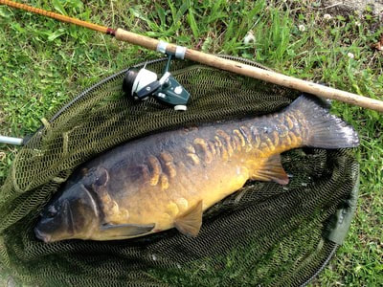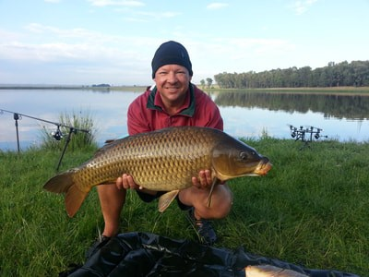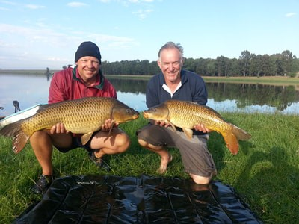
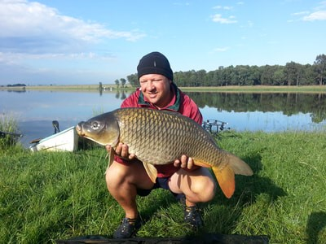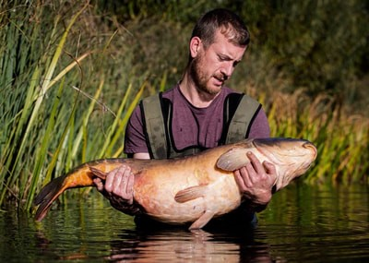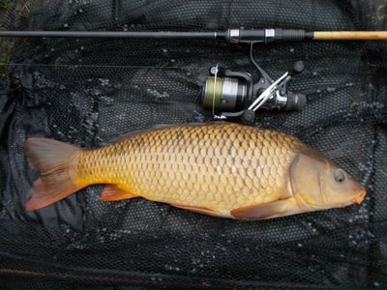
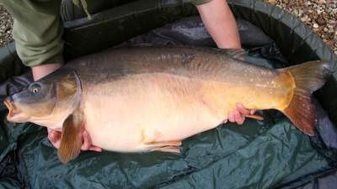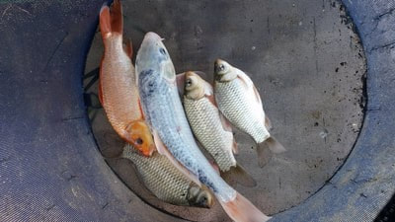

​These are examples of what will not be allowed.
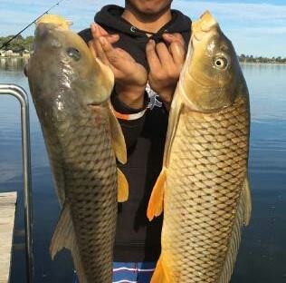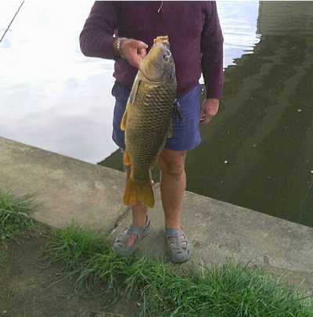
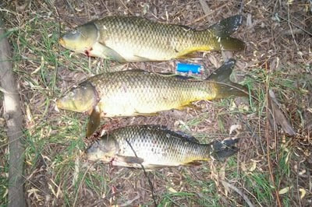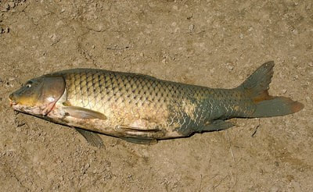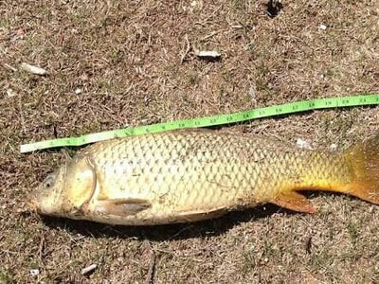

​11. MARKETING BY BUSINESSES AND GROUPS:
No person, business or group or any of its employees, associates or members are allowed to directly or indirectly market, trade or promote any service, event, activity or product without the written consent of Bank Angler. These privileges will most likely only be reserved for Businesses and Groups we associate with and whose intentions are to add value for our members or assist us in achieving our goals.
12. REGISTERING A RECORD:
12.1 Only fish caught during an event hosted or controlled by a Bank Angler Club or the Bank Anglers Angling Association will be eligible to be recognized as a record.
12.2 The weigh-in must be witnessed by the angler, a committee member and at least one other member. Their details and signatures must also be recorder on the Record Application form. The same form can be used for State and National records. The Angler will receive an Official Record Conformation.
12.3 Ensuring the record is recorded remain the responsibility if the Angler.

13. DISCLAIMER:
13.1 It is clearly understood and accepted that any person or persons participating or attending events or competitions do so at their own sole risk and any such person shall not claim against or hold liable the club, the committee or any official or servant or other persons appointed by or acting on behalf of the said organisers or in connection with the contest for any injuries or loss suffered by himself or herself or any other person to by any act, omission or negligence on the part of the committee or any other sponsors or official servants as aforesaid.
13.2 Competitors and other attendants shall indemnify the Club, Committee or other sponsors and the official servants and the other persons aforesaid against the claim by any other entrant or person whosoever or howsoever arising.
12. The organisers may at any time before the commencement or during the Contest, refuse to accept and/or reject entry without assigning any reason thereof and without being in any way whatsoever liable to any person whatsoever for so doing.

